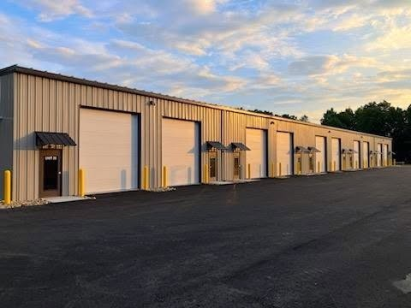
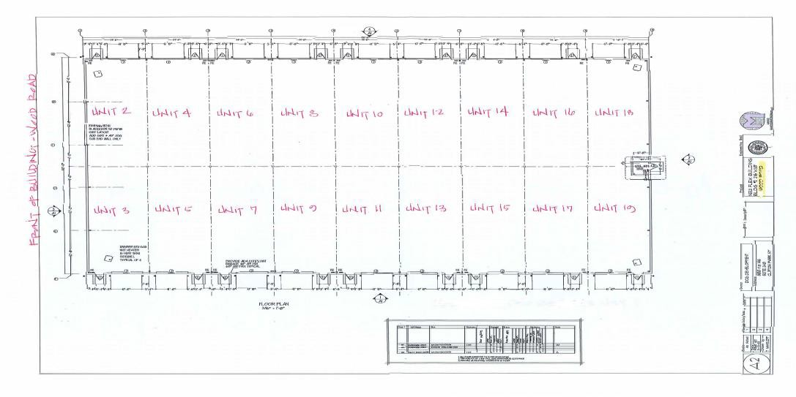
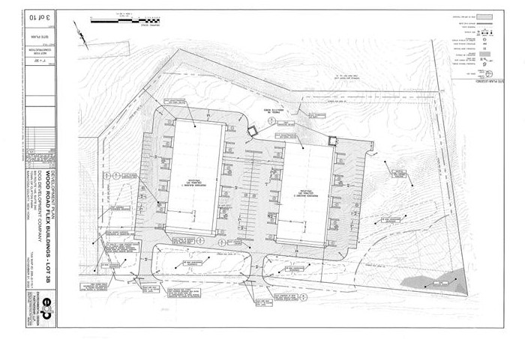
30 WOOD ROAD
NOW LEASING
Immediate Occupancy Available
26,400 sf. Sub-dividable to 1320 sf
3 Phase Power
18’ Minimum Ceiling Height 14’ Overhead Doors
Gas Heat
13.95 psf. Plus Utilities NNN Included Less than 1 mile from I-87, Exit 10
DCG Development
(518) 371-RENT (7368)
DCGDevelopment.com

NOW LEASING
For July Occupancy
26,400 sf. Subdividable to 1320 sf
3 Phase Power
18’ Minimum Ceiling Height 12’ Overhead Doors
Gas Heat
13.95 psf. Plus Utilities NNN Included
Less than 1 mile from I-87, Exit 10

